Job Aid
Core Value, Healthy Workforce Goal

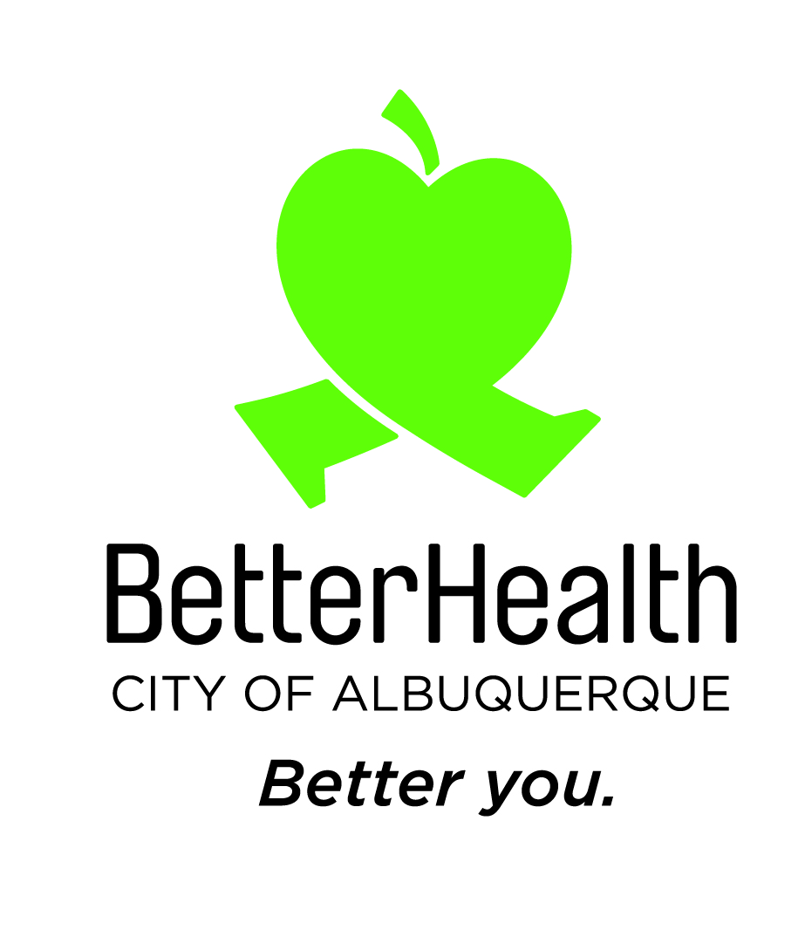

Step by Step
Healthy Workforce Goal

TASK #1
Clarify expectation
Step 1: Share with the employee that the annual healthy workforce goal progress is acknowledged and noted but not scored.
Note: Check-In: As human beings and employees, we want and need to feel seen and heard.

TASK #2
Understand that everyone has wellness aspirations
Step 1: Share with the employee (in your own words) that ‘wellness is the active pursuit to understand and fulfill your individual human needs—which allows you to reach a state where you are flourishing and able to realize your full potential in all aspects of life.’  i. WORK SATISFACTION  ii. PHYSICAL HEALTH  iii. EMOTIONAL WELL-BEING  iv. SOCIAL CONNECTION  v. FINANCIAL STABILITY |  | 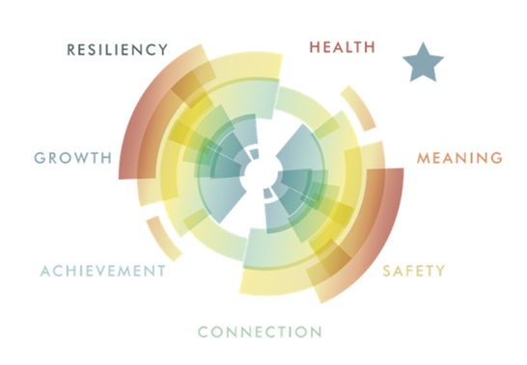
Resource: WELCOA Definition of Wellness 2022

TASK #3
Engage in conversation
Step 1: Ask the employee, On a Scale from 1-to 10, where would you place yourself on your well-being?  Imagine a ladder with steps numbered from zero to 10, zero at the bottom, and ten at the top. The top of the ladder represents the best possible life for you, and the bottom of the ladder represents the worst possible life for you. On which step of the ladder would you say you stand right now?  On which step do you think you will stand about five years from now?  -What are you doing to improve your well-being?  -What can the organization do to provide support and help you improve your place on that ladder?  - What can the organization do to improve its well-being?  Note: This information collected will be shared with the City’s Wellness Coordinator and help guide improvements and offerings. | 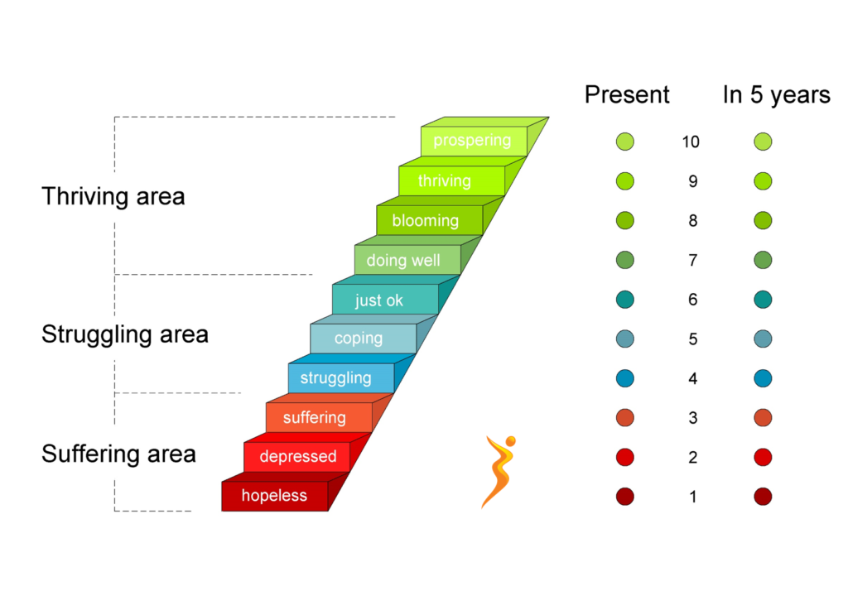

Decision Flow Chart
Role Play - Healthy Workforce Goal

Step 1: On a scale from
1-10, where would you place yourself on your well-being?
What are you doing to improve your well-being?
Step 2: Employee has an answer on what they are doing to improve their well-being.

If NO, proceed to step 2a; if YES, proceed to step 2b
Step 2a: Wellbeing has a broad spectrum of meanings. Here is a handout that may help.
Step 2b: What can the City do to support and help you?
Step 3: Here are some programs/resources we can connect you with immediately.
Step 4: Information collected will be shared with the City’s Wellness Coordinator and help guide improvements and offerings.

